**MA4881 Air Traffic Management**

**Tutorial Air Navigation System**

**Date Release: 5th Feb 2020**

**Student Name:_____________________________Student ID______________________**

**Tutorial Exercise 1: Radio Navigation Simulation**

1. **Navigation using ADF instrument**

This exercise helps you to understand the interrelationship between the position of the airplane, the NDB station and the corresponding reading of the ADF instrument in the airplane.

Click on following link: <https://pyrochta.ch/de/index.php/r-nav/adf>

* Run Navigation Exercise
* Tune->Identify->Compute MB->Rotate->Align->Turn->Stay
* Set Plane Speed to 5 from Plane Speed Menu
* Select Plot Track from Plotter Menu

Magnetic Heading (Aircraft) +/- Relative Bearing (ADF) = Magnetic Bearing (to the station)

MH = aircraft magnetic heading

RB = Relative bearing

MB = Magnetic Bearing (to the station)

Show to your tutor that you can simulate an NDB interception. Take a Screen Snapshot and attach here.

1. **VOR Trainer**

This exercise will help you to understand the interrelationship between the position of the airplane, the VOR station and the corresponding reading of the VOR instrument in the airplane.

Click on following link: <https://pyrochta.ch/de/index.php/r-nav/vor>

* Run Navigation Exercise
* Tune->Identify-> Rotate OBS (TO Flag) ->Align->Turn->Stay
* Set Plane Speed to 5 from Plane Speed Menu
* Select Plot Track from Plotter Menu

Run exercise and repeat until you master it. Show to your tutor that you can simulate a VOR interception. Take a Screen Snapshot and attach here.

**Tutorial Exercise 2.** Position Fixing using VOR-VOR and VOR-DME

Go to website <https://skyvector.com/>.

Type OSH in the top left hand corner airport search text box.

The map will centre on OSHKOSH airport.

There is a VORTAC (OSH) located at the airport.

Type STE in the top left hand corner airport search text box.

The map will centre on STEVENS POINT airport.

There is a VORTAC (STE) located at the airport.

Both the airports are in close vicinity of each other.

1. Identify and mark on the map the location of a VFR aircraft, flying at an altitude of 5500 ft AGL, on the section map, when the Aircraft is on OSH VOR Radial 300 Degrees and STE VOR Radial 150 Degrees.
2. Identify and mark on the map the location of a VFR aircraft, flying at an altitude of 5500 ft AGL, on the section map, when the Aircraft is on OSH VOR Radial 300 Degrees and OSH DME = 20 NM

Show it to your tutor and submit screen shot.

**Tutorial Exercise 3.** In the Sky vector (https://skyvector.com/) locate SHANNON Airport near BALTIMORE-WASHINGTON VFR TERMINAL AREA and answer following questions

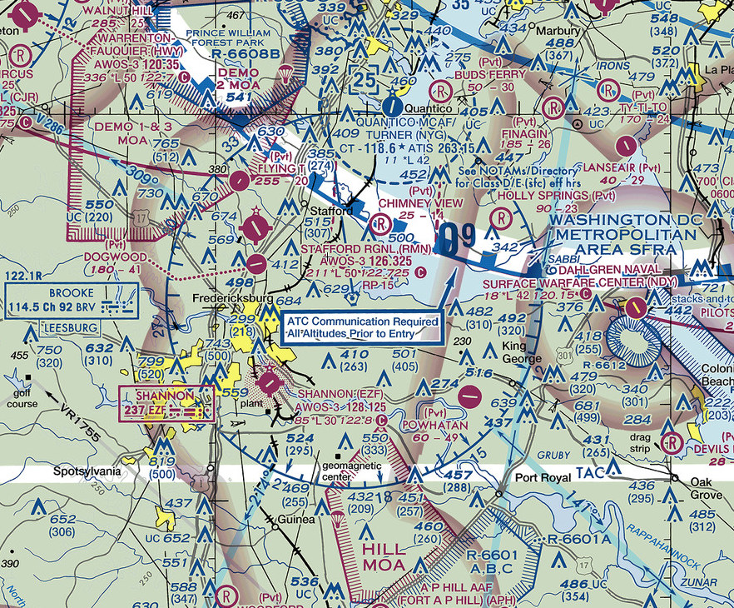

1. What is the three letter Identifier for SHANNON Airport?

2. How many runways does SHANNON Airport have?

3. What Direction (e.g. North/South, North-west/South-east) is the runway(s)?

4. What is the Length of the runway(s)?

5. What class airspace surrounds SHANNON Airport?

6. What is the elevation at SHANNON Airport?

7. What type of (enroute) navigation aid is located *at* SHANNON Airport?

8. What frequency should be tuned, on the aircraft navigation radio to receive signals from the navigation aid is located *at* SHANNON Airport?

9. What frequency should be tuned, on the aircraft voice radio to make communicate on the UNICOM channel *at* SHANNON Airport?

10. Name 3 landmarks in the vicinity of SHANNON airport?

11. What type of (enroute) navigation aid is BROOKE (located directly northeast of SHANNON Airport)?

12. What frequency must be tuned to receive signals from BROOKE (enroute) navigation aid?

13. What is the name of the airway on the 141º radial from BROOKE?

14. What is the name of the airway on the 214º radial from BROOKE?

15. What is the distance in nautical miles between BROOKE and the next navigation aid (not shown) on the 141º radial from BROOKE?

16. What is the name of the intersection on the 141º radial from BROOKE that intersects with the V-376 airway used for approach to Washington?

**Tutorial Exercise 4.** Develop a Navigation Log:

Develop Navigational log for a VFR Flight from Frankfort Airport to KOKOMO Airport; see red circles around the two airports in the map below. Use website <https://skyvector.com/>and type three letter ICAO code for Frankfort Airport (FKR) in the text box next to GO button.

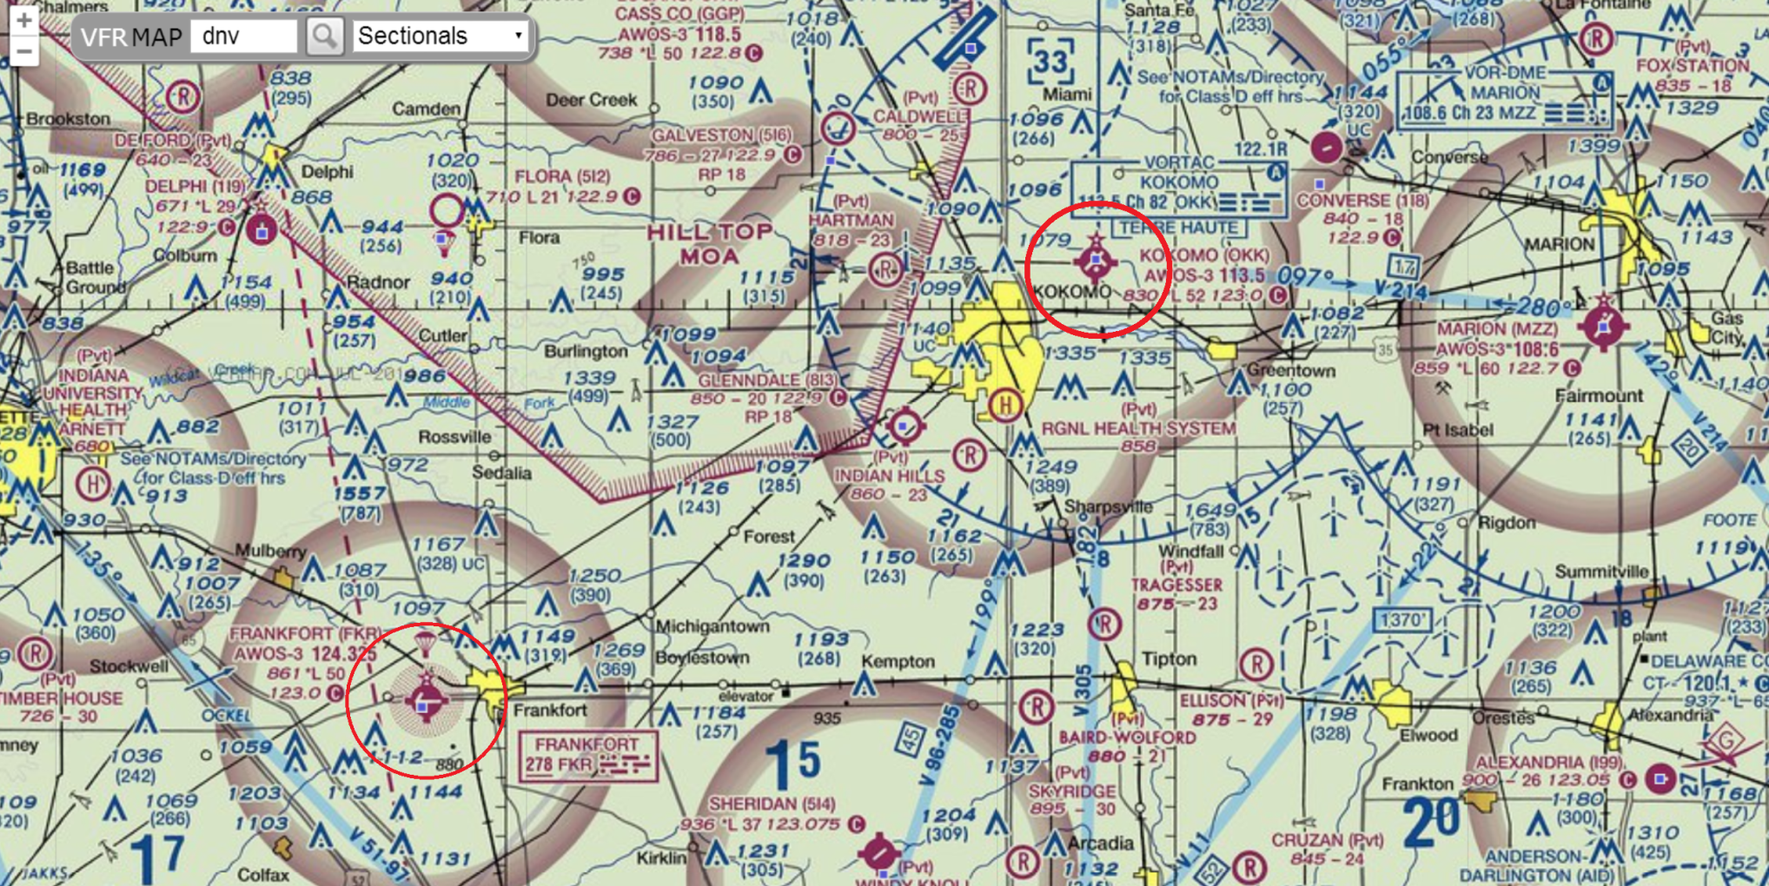

**Fill out a Navigation Log (double click to enable embedded Excel file) as follows:**

**Ensure that you have the sectional map open/printed**

1. Draw a course line, or route, on the sectional from your departure point to your destination
2. You can chose to go direct from point to point or non-direct with multiple segments
   1. As an example, a non-direct route may provide better check points or the ability to navigate using VOR
   2. On the Map place and label tic-marks in 10 mile increments going from departure to destination
3. Conduct a ‘map recon’ by surveying the type of terrain over which you will be flying
   1. Is it suitable for an off-airport emergency landing? _______________________________
   2. Determine the minimum safe altitude for the route (Look for towers, hill tops, etc.)_____________________
   3. Determine the type of airspace being traversed, for example (but not limited to):
      1. Any prohibited areas? ______________________
      2. Any restricted areas? _______________________
      3. If so, when are they active? _______________________
      4. Any MOAs? _______________________
      5. If so, when are they active? _______________________
      6. Any National Security Areas? _______________________
      7. Any parachute jump areas? _______________________
      8. Any class B, C, or D airspace?_______________________
   4. Look for alternate airports along the route should they be needed for any unforeseen problems or weather___________________
4. Select and write below checkpoints along the route based on following instructions:
   * 1. Pick checkpoints with distinctive features that can be easily identified from the air
     2. Checkpoints used to verify your location along your course are useful only if they can be positively identified
     3. Avoid using single common landmarks, such as water towers, since these can look the same for different locations
     4. Avoid using small towns whenever possible since they all look similar from the air
     5. Intersecting lines provide good landmarks, such as a combination of intersecting roads, railroad tracks, rivers, pipelines, and/or power lines
     6. Parts of rivers can be good landmarks if they exhibit truly distinguishing characteristics
5. ___________________________
6. ___________________________
7. ___________________________
8. ___________________________
9. ___________________________
10. Fill out checkpoints in the navigation log as indicated below
    1. Calculate the Course and Distance between each flight legs
    2. Determine the best altitude for the course
       1. When above 3,000 ft AGL fly:
          1. 0° to 179° - Odd thousands MSL plus 500 feet
          2. 180° to 359° - Even thousands MSL plus 500 feet
11. Wind and Temperature information (at all altitude levels) is as follows:
    1. Wind Direction 200 Degrees
    2. Wind Speed 29 knots
    3. Temperature 15 degree Celsius
12. Compute and fill in the true airspeed (TAS) for the route segment being flown
    1. Fill in the flight planed calibrated airspeed (CAS)

CAS can be found in the Pilot Operating Handbook of an Aircraft (**Use 110 Knots as average speed**)

* 1. Compute TAS based on the altitude selected and the reported temperature.

Fill out CAS and TAS accordingly in the navigation log

1. Compute the true heading (TH)
   1. True heading (TH) is true course (TC) corrected for winds
   2. Correct the true course for the winds and note the wind correction angle (WCA) or Drift Angle
   3. TH = TC – Drift (East) or TH = TC + Drift (West)

Fill out accordingly in the navigation log.

1. Compute the magnetic heading (MH)
   1. Magnetic heading (MH) is true heading (TH) corrected for variation
   2. MH = TH + West Variation, or, MH = TH – East Variation
      1. Magnetic variation is found by locating the closes isogonic line to your route
      2. Isogonic lines are the dashed magenta lines on the sectional
         1. Will depict the degrees of magnetic variation (i.e. 4°E, 6°W, etc.)
            * Add westerly variation to true course
            * Subtract easterly variation from true course
   3. Fill in the magnetic variation in the navigation log, compute the magnetic heading

Fill out accordingly in the navigation log.

1. Measure distance
   1. Measure each segment as well as the total route
   2. Note the distance on the navigation log according to the next few steps:
      1. Note the total distance at the top of the column as a beginning point
      2. Note the leg distance for the next leg on the next line down
      3. Subtract that leg distance from the distance above it to derive the distance remaining and note it on the next line down
      4. Repeat steps ii – iii for all remaining legs

Note accordingly in the navigation log

1. Compute your estimated ground speed (GS) and note it on the navigation log
   1. The top box of the leg is for the estimate
      1. Fill it out during flight planning
   2. b. The bottom box of the leg is for the actual ground speed computed during flight
      1. Leave it blank

Fill out each leg’s estimated GS on the navigation log.

1. Compute the estimated time enroute (ETE) and estimated time of arrival (ETA) for each leg

a. Compute the ETE in minutes and seconds for each leg using Speed = Distance/Time Formula

b. Add the ETE to your estimated time of departure for the first ETA

c. Add the ETE to the preceding ETA for the remaining legs

Note each leg’s ETE and ETA on the navigation log

1. Complete Airport Frequencies in the Navigation log below (double click to edit embedded excel file)

